Manual for firmware of FNIRSI 1013D oscilloscope (YAPOK or DANIU)
Important!!! You do everything at your own risk.

Added features compared to the original version:
- The possibility of adding date and time to the preview of images, timestamps written to saved files, displayed time on the main screen. ( RTC module installation required )
- The possibility of changing the sampling frequency and time per division. (allows you to display more samples, e.g. see more packets on the i2c bus)
- The number of samples taken is always 3000. ( originally 1500 or 3000 samples )
- Progress progress across the entire buffer. ( in the range of 0 to 3000 samples )
- Added values of voltage cursors separately for channel 1 and channel 2 and display of delta Y value.
- Refined measurement menu, possibility of quick selection (select all, clear, hide) of displayed values of voltage, frequency, etc.
- Quick sensitivity setting from the channel menu.
- Trigger value set separately for channel 1 and channel 2.
- Works from 0mV ( The original does not display a signal below/above 6 signal units, ie on a range of 100mV/div it only displays a signal greater than 30mV )
- Firmware saved on SD card (original in flash chip on pcb)
- Removed many bugs of the original firmware.
- Open source code.
- Regular firmware update (it is still under development) – the applicable version is v0.023x
- FFT is not yet available.

Firmware update

The firmware is stored on the sd card in a reserved part in sectors 0 to 2048. The oscilloscope settings are stored from sector 709 onwards. Configuration data for the display and touch pad are stored starting from sector 710.
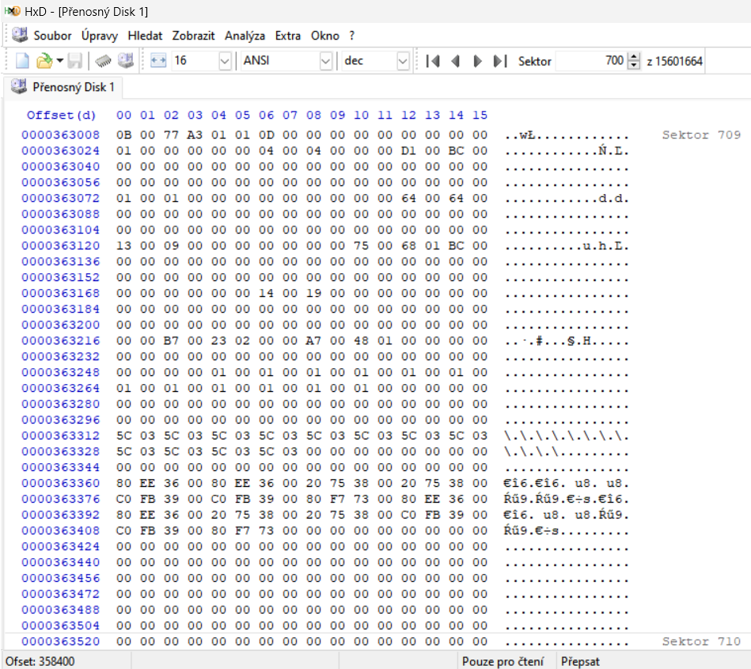
The Linux console or the Windows LOADER program can be used to write data.
By default, an 8GB card has a dedicated 1MB section at the beginning of the card, where the given firmware is written. If this section is not available (or a smaller card is used), an error will occur when writing with the LOADER program. The card must then be formatted correctly. And repeat the firmware upload.
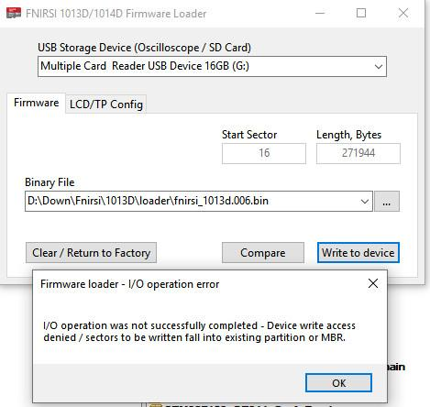
Original text: https://www.eevblog.com/forum/testgear/fnirsi-1013d-100mhz-tablet-oscilloscope/1525/

WINDOWS solution:
You can check the offset of the first partition using the command line:
DISKPART
LISt DISk
SELect DISk * (use appropriate disk number here)
SELect PARtition 1
DETail PARtition ("Offset in Bytes" is the value you are interested in)
EXIt
Offset 1048576 bytes is the default for 8 GB and larger devices, partitioned using Windows. This offset leaves about 1 MB of free space for oscilloscope firmware.
But if Windows formats an already partitioned device with less free space, it DOES NOT CHANGE the existing offset. You need to delete the partition and create it again.
Command line way:
DISKPART
LISt DISk
SELect DISk * (use appropriate disk number here)
CLEar
CREate PARtition PRImary
EXIt
Disk Manager way:
Find your card, right click on partition, select "Remove Volume", confirm.
One more right click, select "New Single Volume", next, next, next... You may leave everything as default.
After creating the partition, you need to format it as FAT32. Then use my loader, it should work without errors.
Please note that the default offset for 1..4 GB devices is 65536, so there will not be enough space for oscilloscope firmware without special repartitioning.

Video for formatting a card under Linux Ubuntu:

FNIRSI1013D fix sdcart problem with load firmware
https://www.youtube.com/watch?v=4yFmStYuK_o

Calibration of input dividers

When uploading the firmware, you will be warned about the need to calibrate the input dividers!
Each oscilloscope is equipped with resistance dividers at the input. So everyone will show different voltage values on the screen. Because of this, calibration of the input divider values is required.
In the oscilloscope menu, click on the option Base line calibration.
The required calibration voltages for the ranges are:
- 100mV/div 300mV
- 200mV/div 600mV
- 500mV/div 1.5V
- 1V/div 3V
- 2.5V/div 7.5V
- 5V/div 15V
Use an analog voltage source, or battery voltage that has zero ripple.

The recalibration of the input dividers can be invoked via the USB connection menu by clicking on the exact center of the PC screen and confirming by clicking on the OK item to reset the calibration data.

Distribution of data in memory (SD card)

#define SETTINGS_SECTOR 709 //old 700 Location of the settings on the SD card for now

Names | offset | All bytes | Used bytes | Use File setup
CHANNEL1_SETTING_OFFSET | 8 | 24 | 9*16bit=9 | 18*16bit
CHANNEL2_SETTING_OFFSET | 32 | 24 | 9*16bit | 18*16bit
TRIGGER_SETTING_OFFSET | 56 | 24 | 8*16bit | 10*16bit
OTHER_SETTING_OFFSET | 80 | 24 | 9*16bit | 8*16bit
CURSOR_SETTING_OFFSET | 104 | 16 | 6*16bit | 6*16bit
MEASUREMENT_SETTING_OFFSET | 120 | 32 | 26*16bit | 26*16bit
CALIBRATION_SETTING_OFFSET | 152 | 16 | 12*16bit
CALIBRATION_SETTING_OFFSET_C | 168 | 8 | 4*16bit
INPUT_CALIBRATION_SETTING_OFFSET | 176 | 32 | 14*32bit=28
 | Next 192

Long mode (scroll mode)

- Long time base 100ms/div to 50s/div. In the waveform view mode, the range is from 20ms to 50s/div (multiple zoom options)
- Long time base uses a memory of 3000 samples per channel.
- In the long mode, the menu of measured values is not displayed.
- Trigger options: Normal and single with the option of setting the trigger level and type of edge. Auto free run mode, no triggered.

Measurement menu:
Selection options:
- All - selects all items
- Clear - cancel all selected items,
- Hide - hides the display of selected items

